How to load before 2 or 3 dayes file to gen2 and break point,deactive

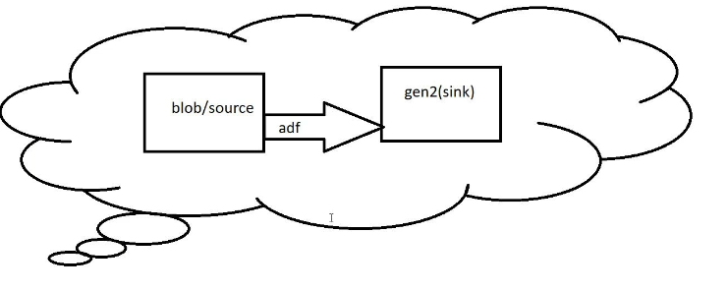
Create blobstorage: and input container
I need to copy the before two days file means if today is 7/16/2024 I need to copy the files 14th means 7/14/2024 means need to ignore the 12 th 13 th day files
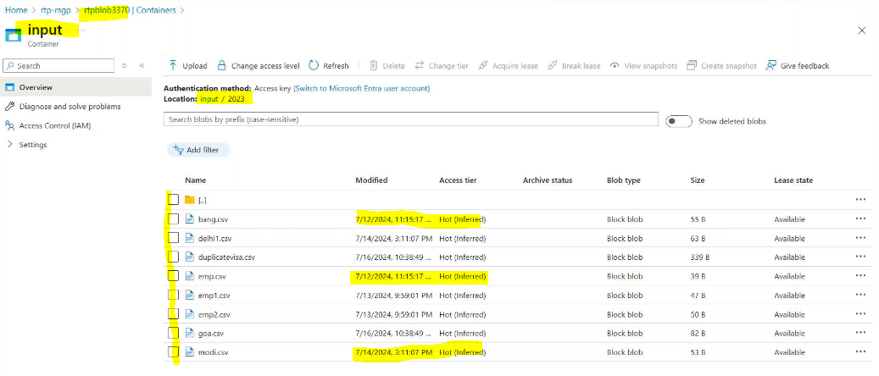
Create gen2 storage:
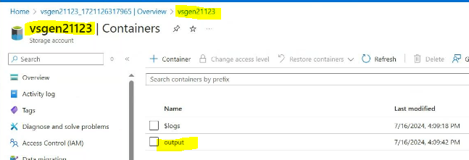
Create integration run time:
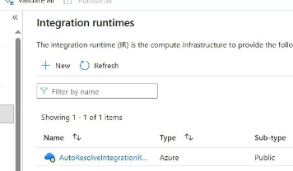
In linked services authentication type we need provide the all System managed identtites.
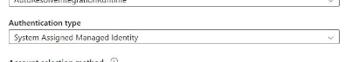
For that we need add assign roles in blob and managed identity services also

Go to blob storage
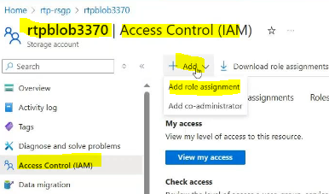
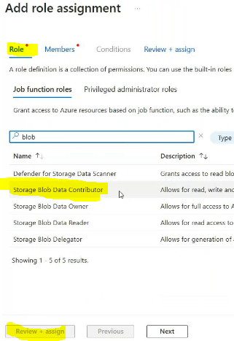
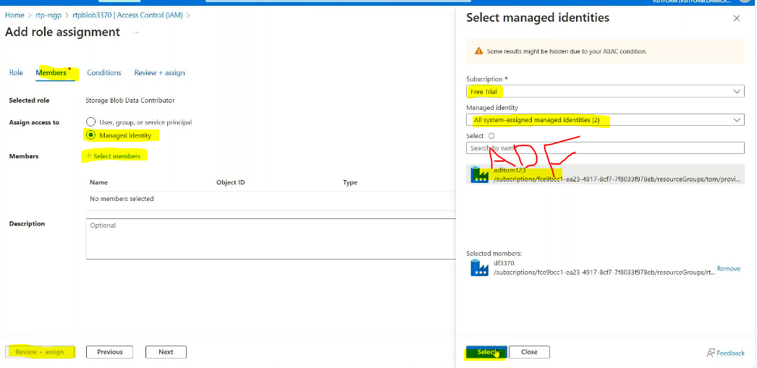

Create a managed identity
Search it in search bar
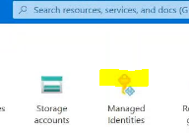
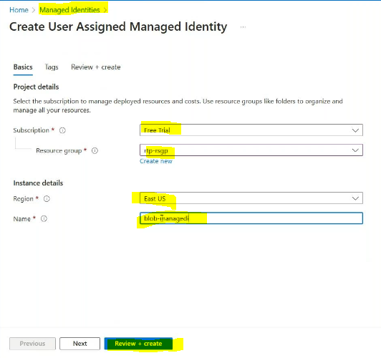
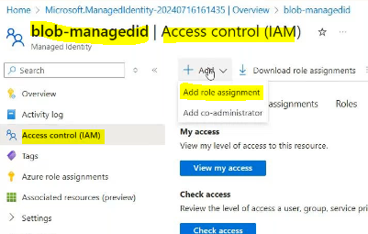
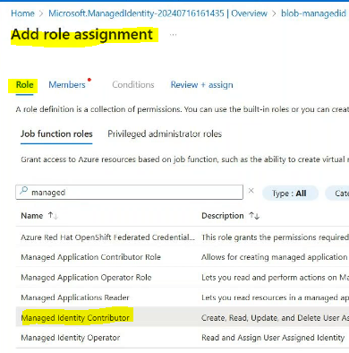
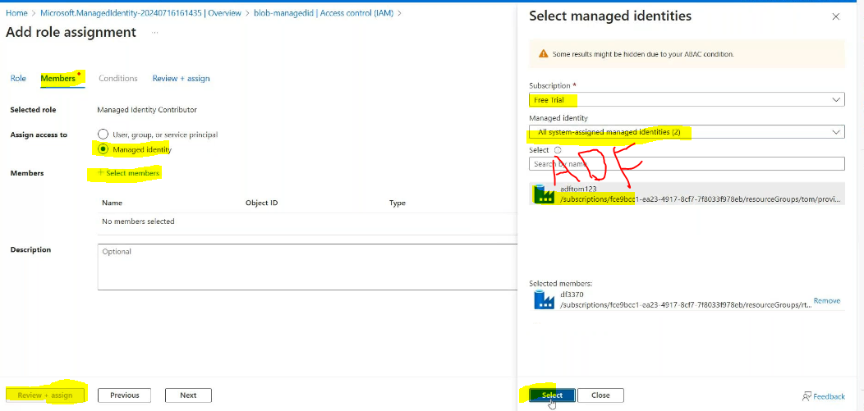
Create linked services for blob or source side:
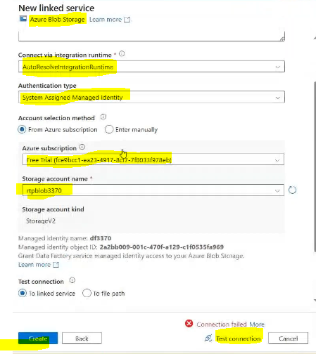
Create linked services for sink side:
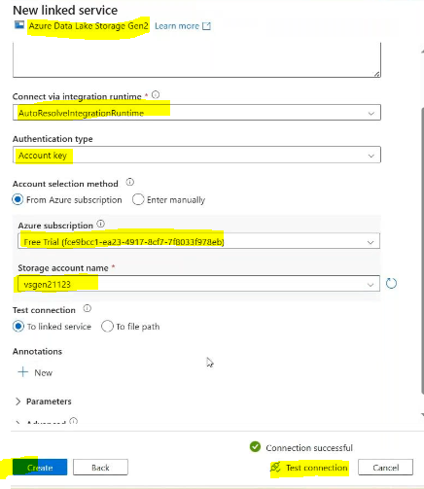
Like this :
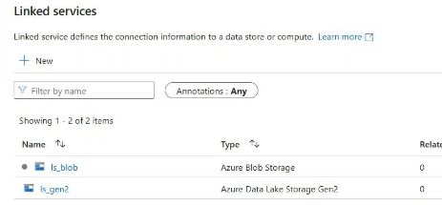

Create source datasets:
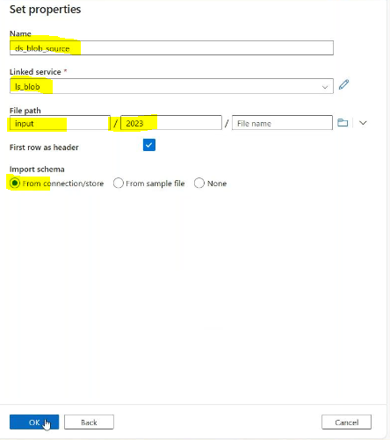
Create sink side datasets:

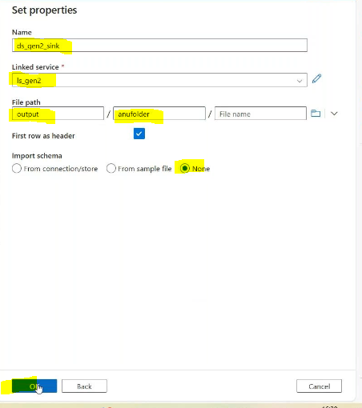
Create pipelinecopy data activitysource sideprovide blob_lk
In filter by last modifiedstarting time add dynamic provide the below syntax

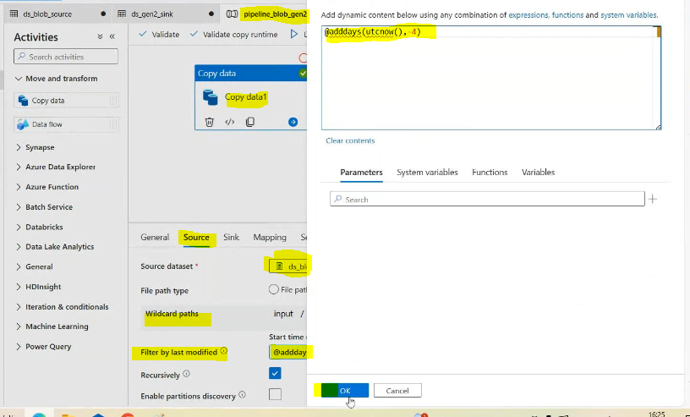
End time :
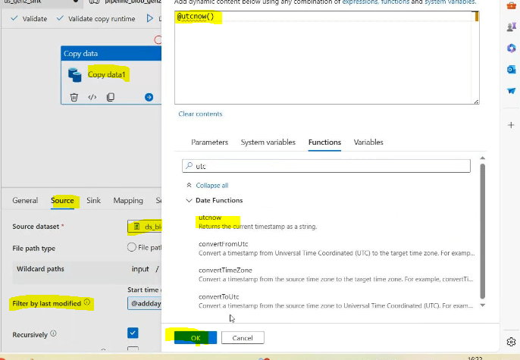

In source side it seems to be like this after config
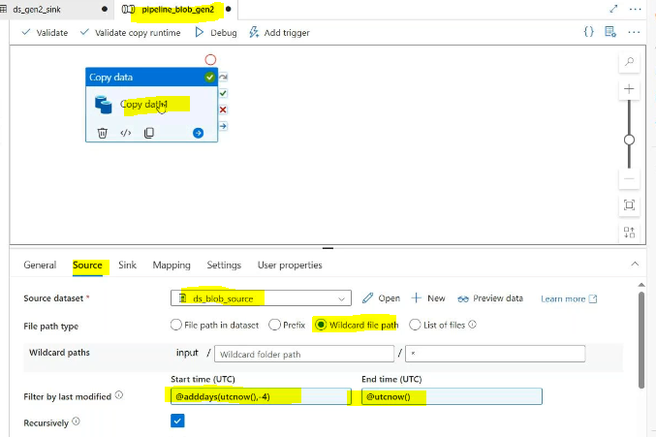
Sink side:
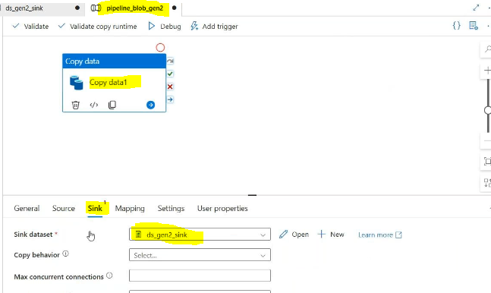

Result:
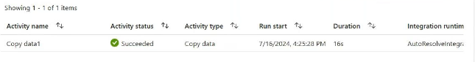
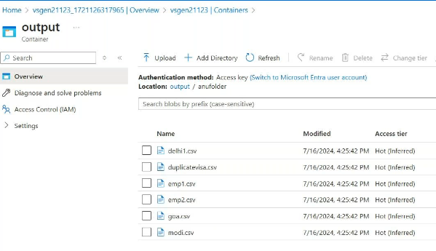
Campaire with input: it will ignore the bang and emp files
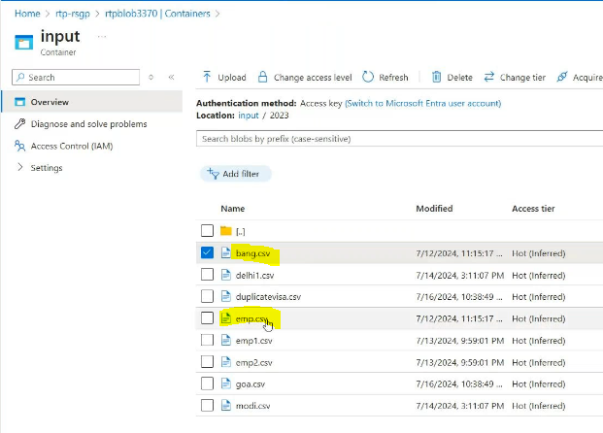

Wait activity

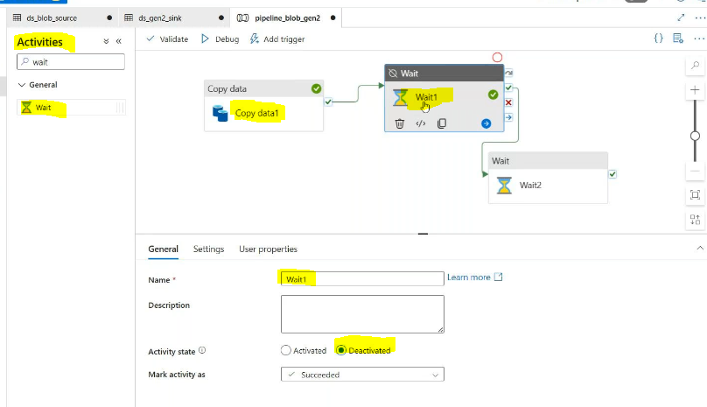
If we are deactivity in middle of the wait activitycopy data and wait2 activity will excutes
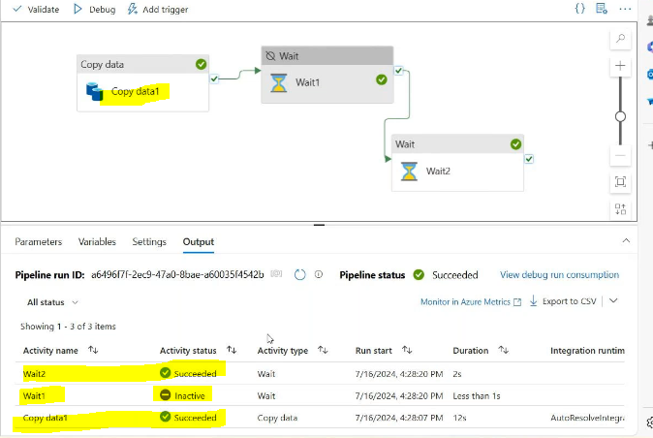

Break point
If copy data activity has a break point right side of the wait activates are can’t executed
